Crop Deal Low Level Design(LLD)

Contents
1.0 Document Purpose ............................................................................................................. 3
2.0 Intended Audience ............................................................................................................. 3
3.0 Project Background, Objective(s) .....................................................................................4
3.1 Project Background.....................................................................................................4
3.2 Project Objective......................................................................................................... 4
4.0 Design Pattern .................................................................................................................... 4
5.0 Solution Diagram ............................................................................................................... 5
6.0 Architecture Diagram ....................................................................................................... 5
7.0 Flow Diagram .................................................................................................................... 6
8.0 Use case Diagram............................................................................................................... 7
9.0 Class Diagram ................................................................................................................... 7
10.0 E-R Diagram ................................................................................................................... 8
11.0 Data Model ...................................................................................................................... 8
12.0 Solution Steps.................................................................................................................. 9

1.0 Document Purpose
This document serves the purpose of delivering a comprehensive overview of the solution architecture devised for the CropDeal project.
2.0 Intended Audience
This document is meticulously crafted to serve as a pivotal point of reference for various roles and stakeholders with a vested interest in comprehending the technical intricacies of the CropDeal project.
Role | Nature of Engagement in WB Classics Portal Technical Architecture
Product Owners/SMEs | As key stakeholders, their primary responsibility is to ensure that the architecture aligns seamlessly with the overarching business goals of the CropDeal project
Business Analysts | Business analysts are integral stakeholders, kept abreast of critical architectural decisions, fostering a unified understanding of the project's technical underpinnings.
Enterprise Architects | These architects play a vital role in ensuring that the Platform Architecture is not only in harmony with business goals but also adheres meticulously to architectural guidelines, ensuring a cohesive and strategic alignment.
Solution Architects | Solution architects are entrusted with the responsibility of guaranteeing that the solution design and architecture are finely attuned to business requirements and architectural guidelines, thus fostering an optimal and efficient system.
Developers | Developers are encouraged to utilize this document as a guiding beacon for detailed design and implementation strategies. This approach ensures that their efforts align seamlessly with the CropDeal Microservice framework, contributing to the overall success of the project.

3.0 Project Background, Objective(s)
3.1 Project Background
The inception of the CropDeal microservice stems from the intention to simplify the lives of farmers. The platform empowers farmers by providing them with a means to showcase and sell their crops directly to dealers. A noteworthy feature of this service is the elimination of the necessity for farmers to incur commissions.
3.2 Project Objective
The primary aim of CropDeal is to serve as a pivotal connection point between farmers and dealers. This involves a streamlined process of registration for both farmers and dealers. Farmers are afforded the opportunity to list their crops on the platform, while dealers can facilitate direct payments to the farmers' accounts. This approach not only enhances the efficiency of the agricultural trading process but also contributes to the financial well-being of farmers by cutting out intermediary costs.

4.0 Design Pattern
Sr.No. | Name | Description
1 | ANGULAR | Angular is used for the frontend and designing of the single page application
2 | API | Api is used to process all the http Requests.
3 | SQL SERVER | SQL server is used to store data to the database

5.0 Solution Diagram
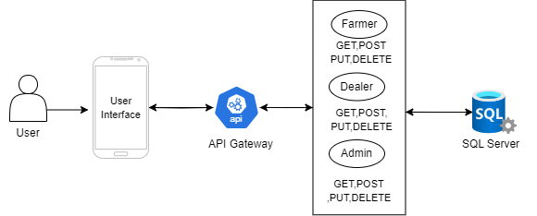

6.0 Architecture Diagram
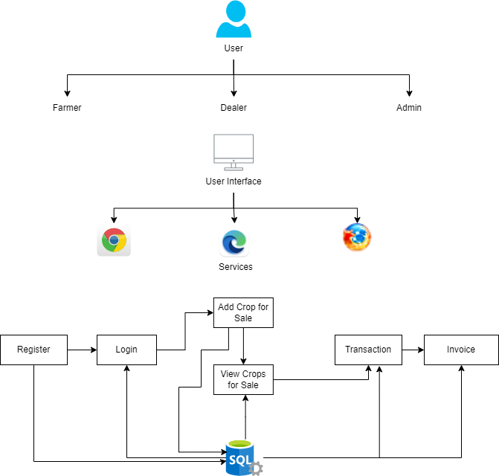
7.0 Flow Diagram

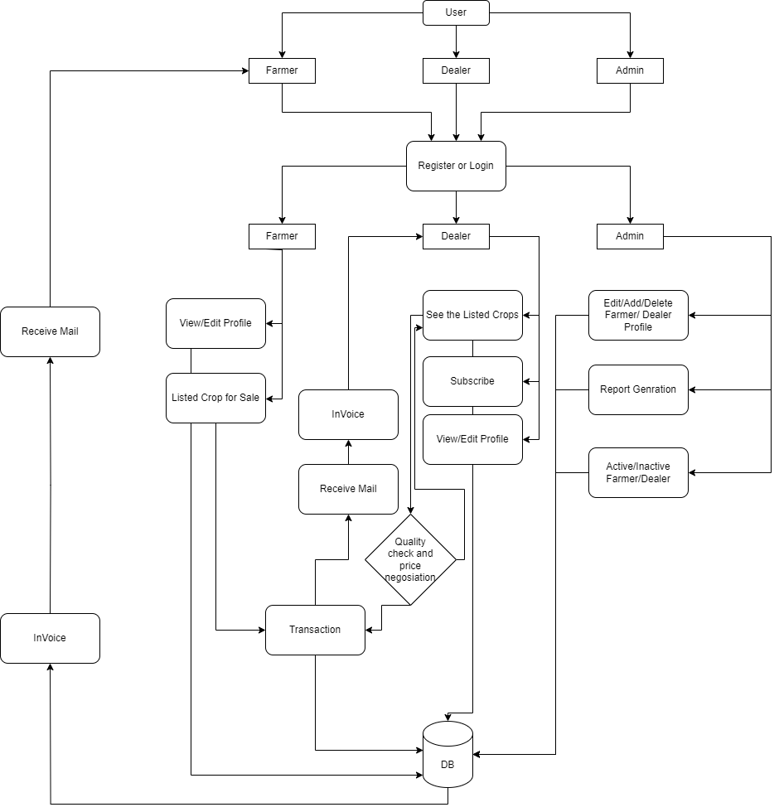
8.0 Use case Diagram

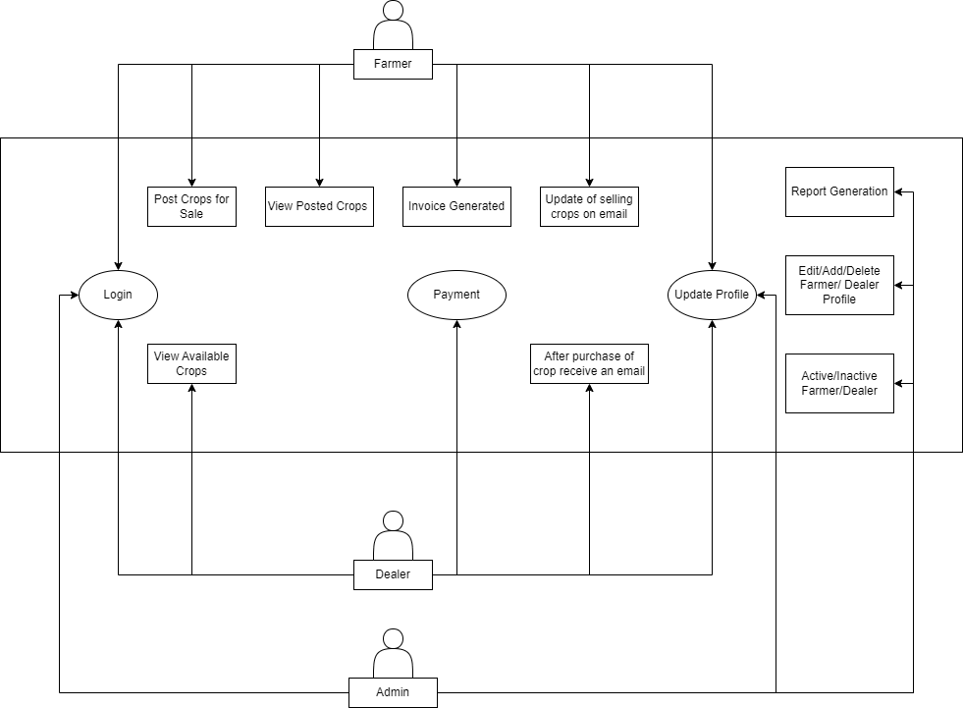

9.0 Class Diagram
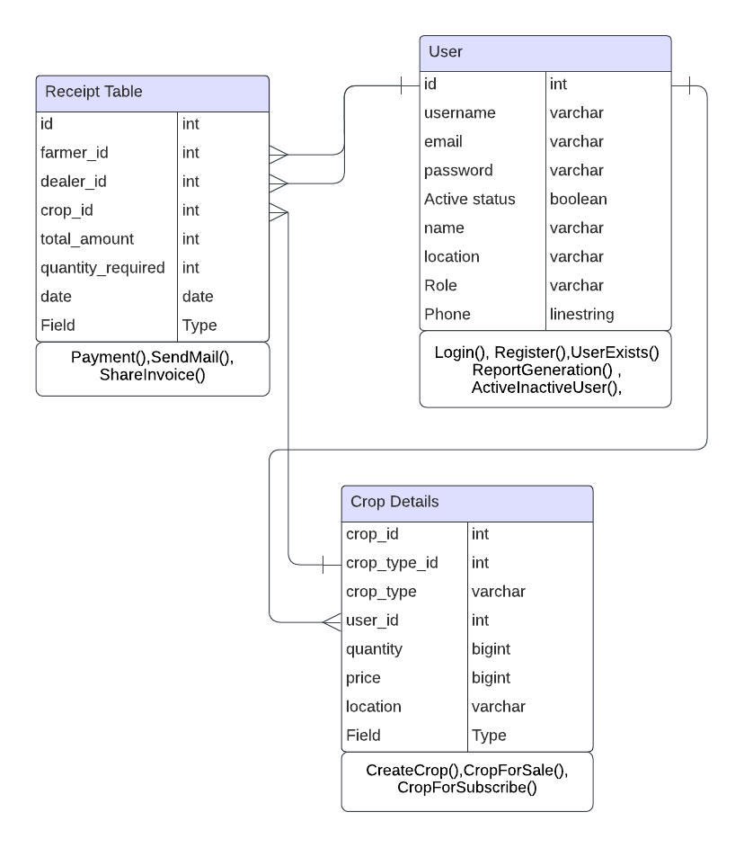

10.0 E-R Diagram

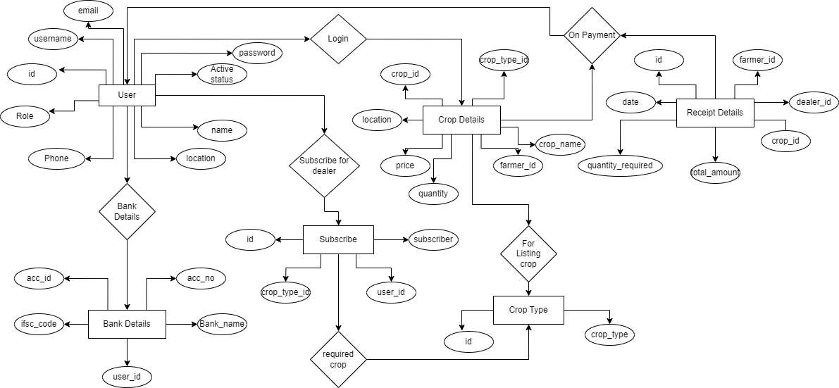

11.0 Data Models

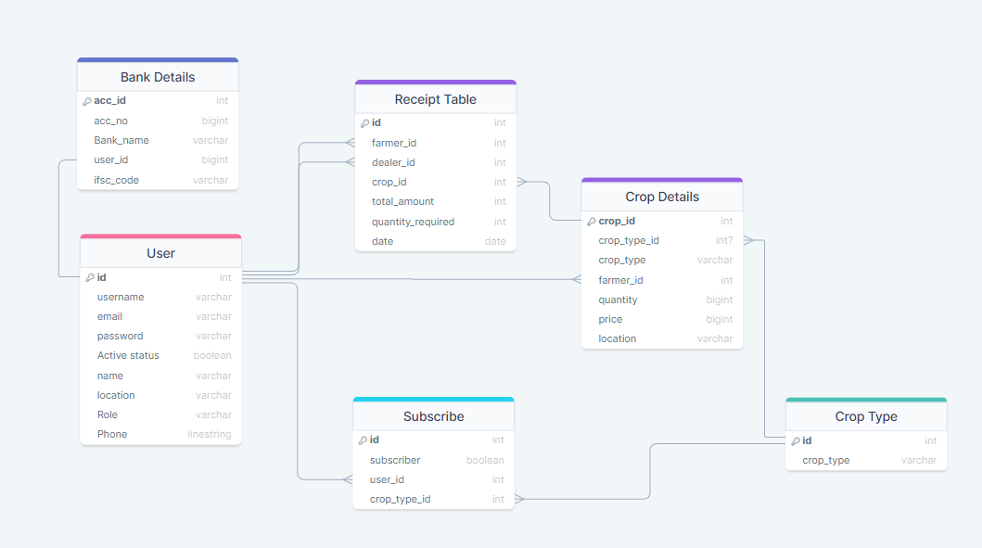

12.0 Solution Steps

12.1 User Registration
- The user will select their role as a farmer or dealer.
- The user will enter the name, phone Number, Address and their bank account details during registration.
- The input validation will be done.
  - If validation fails, then it will return the error code and error description. with status code
  - If validation is successful, then the User details is stored in the database and success code is sent.

12.2 Crop Listing
- The Farmer will login using his username and password.
- The Farmer will be posting all the available crops with the Name, quantity, price for sale.
- After posting all the details regarding the crops the farmer will be waiting for the dealers.

12.3 Crops on Sale
- The dealer logins with their username and password.
- The dealer sees the all-listed crops that was listed by the various farmers.
- When the dealer interested in purchasing the crops which was listed by the farmer.
- The Dealer will click proceed button.

12.4 Payment
- Then Dealer will reach the farmer location and checks the quality and weighs the crops.
- If the dealer is satisfied with the crop quality and the quantity.
- He will again login using his login credentials and proceed with the payment.
- After successful payment an Invoice will be generated, and it will be sent to both the farmer and Dealer.

12.5 Admin Module
- Admin will login with his Username and Password.
- Admin can able to filter active/inactive farmers and dealers.
- The admin can get a Dealer’s report when he clicks to generate a particular dealer report.

